**Objectives**

**Design a topology of routers and configure static routing to create two different static routes**

* Ensure you’ve reviewed the lecture slides, module videos and textbook first.
* Read over the entire lab before proceeding and follow instructions carefully. Do not make assumptions.
* Per the lecture slides, it may be helpful to draw the topology diagram first and label the ports and subnet addresses.
* Do not over configure!

**A - Create the Topology**

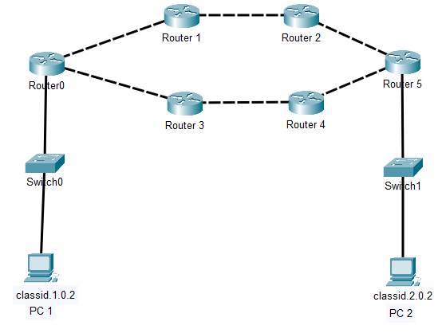

* Add a textbox with your name, Class ID , and “LAB 08B”
* Note: Use a 4331 Router configured with 3 ports
* Connect the switches to the router’s port 0
* Router connections:
  1. R0/Port 1 to R1/Port 2
  2. R1/Port 1 to R2/Port 2
  3. R2/Port 1 to R5/Port 2
  4. R5/Port 1 to R4/Port 2
  5. R4/Port 1 to R3/Port 2
  6. R3/Port 1 to R0/Port 2

**B – Configure the Subnets**

* Configure the two end point subnets: ***classid*.1.0.0 /16** and ***classid*.2.0.0 /16**  
  Example, my class id is 162. My two subnets are 162.1.0.0 /16 and 162.2.0.0 /16
* Configure each PC’s IP address
* Configure each router’s port 0 : ***classid*.1.0.1**  and ***classid.2.0.1 /16***
* Configure the router to router subnets

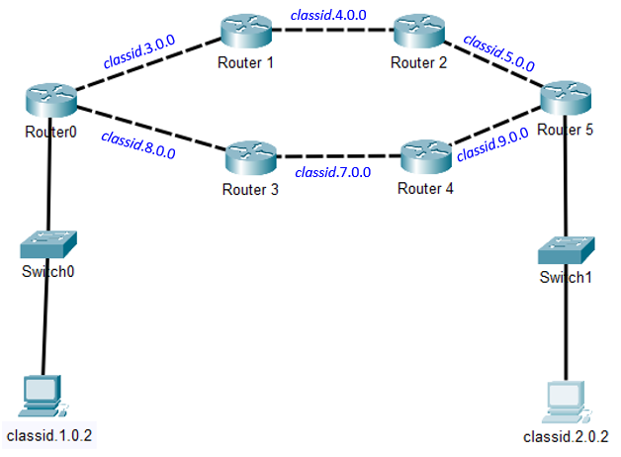

|  |  |  |  |
| --- | --- | --- | --- |
| **Router** | **Port** | **IP Address** |  |
| R0 | 0 |  | gateway |
|  | 1 |  | R0 to R1 |
|  | 2 |  | R3 to R0 |
| R1 | 1 |  |  |
|  | 2 |  |  |
| R2 | 1 |  |  |
|  | 2 |  |  |
| R3 | 1 |  |  |
|  | 2 |  |  |
| R4 | 1 |  |  |
|  | 2 |  |  |
| R5 | 0 |  | Gateway |
|  | 1 |  |  |
|  | 2 |  |  |

**C – Configure the Static Routes**

* We are going to create two different static routes
* The static route to subnet *classid.2.0.0*  will go through the top routers R0-R1-R2-R5
* The static route to subnet *classid.1.0.0*  will go through the bottom routers R5-R4-R3-R0

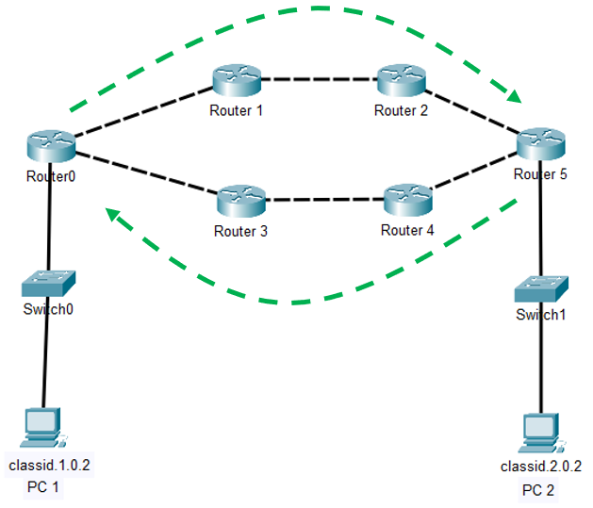

**D – Lab completion**

* In simulation mode: Ping from PC1 to PC2.
* The request ICMP packet should move through the top routers – R1 and R2
* The response ICMP packet should move through the bottom routers – R4 and R3
* If the packet doesn’t flow, debug the router where it stops and the next hop.
  + Are the IP addresses configured correctly
  + Did you use the correct subnet mask 255.255.0.0
  + Is the IP ROUTE command correct?
  + Are you cabled to the correct port?
* Save your PKT file : L08B-*lastname*.PKT.
* Submit only the PKT file in iLearn. *You do not have to write up a lab for this week.*